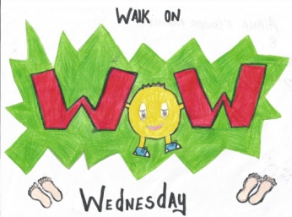
Dear parent(s)/guardians,
Presentation Convent JNS is a GREEN SCHOOL. We currently have 3 green flags, litter and waste, energy and water. This year we are continuing our work towards our 4th green flag –TRAVEL.
As with other Green Schools Programs in the past, we are trying to develop an awareness about sustainable travel eg. walking, carpooling, Park ‘n Stride ( park your car in a car park and walk your child to the school ) or cycling. It is very important that travelling to school should be an enjoyable, safe and healthy experience for children, parents and teachers.
We are doing our W.O.W (Walk on Wednesday) days again starting on Wednesday 16th October. We ask the children to wear a hi-vis vest as they walk or park and stride to school. This year we are running a competition in all classes –the class with the highest number of walkers and hi-vis vests worn will receive a prize and a certificate. Our W.O.W stickers will also be awarded to those who walk to school.
An Taisce , will visit our school during the current year 2013-2014 to assess our progress and determine whether we have done enough to receive our green flag for TRAVEL.
Thank you for your support with our Green Schools Program.
W.O.W. (Walk on Wednesdays) Calendar 2013-2014
16th October 2013 | 5th March 2014
6th November 2013 | 2nd April 2014
4th December 2013 | 7th May 2014
15th January 2014 | 4th June 2014
5th February 2014

