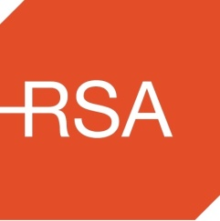
Road Safety Authority

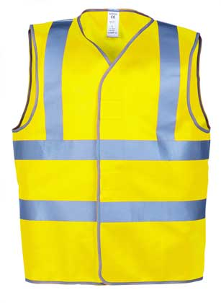
National Hi-Visibility Day

Wear you Hi- Vis Vest
on Saturday 21st December
The Shortest Day of the Year!

BE SAFE! BE SEEN!

