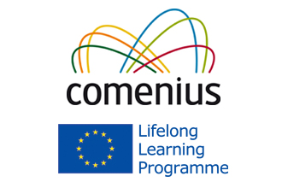

Presentation Schools welcome our Comenius visitors from France, Poland, Slovakia, Spain and Italy. Our visitors will be staying with us from Wednesday 26th to Sunday 30th March. We hope they really enjoy some of the activities we’ve planned for them including GAA sports and a Seachtain na Gaeilge Concert! Míle fáilte do gach éinne atá ag teacht chugainn! Táimid ag súil go mór leis an cuairt!

