Presentation Junior School

Mullingar, Co. Westmeath Tel.: 044-9342166 Fax: 044-9396569

Email: admin_jnr@presentationjnrmullingar.com
Web: www.presentationmullingar.ie
Parent/Guardian
Short Information Booklet
Home and school working together as a
T. Together
E. Everyone
A. Achieves
M. More

Mission Statement
To educate our children to their fullest potential, in an environment where Christian values are fostered, where they are happy, safe, respect themselves and others and where each feels valued.
Ethos
Our school is Catholic in character, inclusive in our intake and comprehensive in our curriculum. Our behaviour management strategies and structures are built on the principles of justice and fairness. We endeavour to fulfil our mission in partnership with management, parents, staff, students, parish and the local community.
Welcome to Presentation Convent Junior School.
We thank you for entrusting your child’s education to our school.
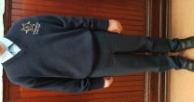
Uniform
Thank you for ensuring your child wears the school uniform every day. The school tracksuit and trainers can be worn on PE day only. Thank you for taking pride in the uniform by ensuring it is clean, tidy and in good condition. We encourage the children to take care of their uniform by changing when they get home each evening. Often we get comments sayings how smart the children look in their uniform when we go on school outings.
Girl’s uniform: Navy pinafore or navy skirt or navy bootleg trousers. Light blue blouse. Navy socks or tights. Black shoes (no high heels, platforms or boots) Trainers for PE day.
Boy’s uniform: Navy trousers. Light Blue Shirt. Navy socks. Black shoes. Trainers for PE day.
School jumper/cardigan with crest available from Tots Paradise, Blackhall Place just off Mount St. and from The Uniform Shop in the Enterprise Centre, Bishopsgate St.
Tracksuit with school logo is available through the school only at a price of €30. A white polo shirt to be worn under the tracksuit top can be bought in any shop.
When you visit the teacher there will be an opportunity to order your tracksuit.
Please put your child’s name and room number on uniform, tracksuit and all belongings. As there may be many similar school coats please think of some way your child can easily recognise his/her coat.
Personal hygiene is very important at all times. Please ensure hair is clean and neat. If hair is long it is best to have it tied back neatly. The school reserves the right to decide what is becoming in dress and appearance. No child can wear jewellery while in school.
Please Note: Children are not to bring a Mobile Phone to School.

Parent Communication.
We believe the relationship between home and school is very important. We encourage you to take great interest in your child’s work in school. Please show interest in the Parent’s Association activities and become involved. Our school needs your participation and talents to be a vibrant place of education. In order to keep you informed of important information we operate a text a parent service. It is vital we have your most up to date mobile number at all times. Please notify us immediately of any change of address, phone or mobile numbers.
Parent /Teacher meetings are held during the year. The teacher may be available for an informal meeting at dismissal time. As teachers have additional work to complete after school please ask teacher if it is convenient to meet. If you wish to speak with the teacher/Principal at other times please contact Reception for an appointment.

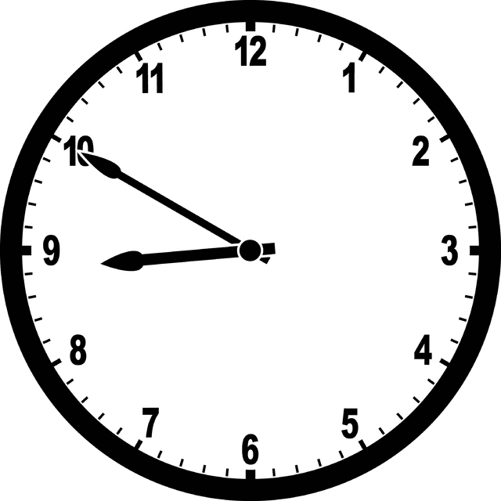
Attendance and Punctuality
School hours are: Junior and Senior Infants 8.50-1.30.
First and Second Classes 8.50-2.30.
It is good training for life to be punctual and all children should come to school on time. If you arrive after 9.10am please escort your child to the yellow door and ring the doorbell.
The school will be open to receive pupils at the official opening time of 8.50a.m.The school accepts no responsibility for:
- children arriving before that time
- children remaining in the school or school grounds after school hours
- children coming to school or going home from school.
Parents and children using the Harbour St. entrance are requested to use the pedestrian entrance only.
Please respect the yellow lines for the safety of our children and park in public car park to drop off your child.
If a child needs to leave school during school hours a parent/guardian must first send a note to the class teacher with details of date, time, the reason and signed by parent/guardian. The parent must call to reception (yellow door) and the Secretary will collect the pupil from the classroom. If your child is in St. Josephs it is school policy that you must first call to Reception. If the parent is sending someone else to collect the pupil this person must have a signed note from the parent saying they give authority to the person to collect the child.
If a pupil is absent the child must bring a note stating the reason.
The note should state the following and be signed by a parent/guardian: Child’s name, room number, reason for absence, illness, family concern, holidays other. (Please see sample note at back of booklet) If a child is absent for more than 20 days we must send his/her name to TUSLA’s Education Welfare Service.
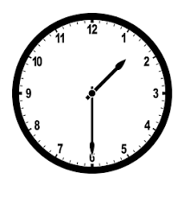
Parents are asked to stand clear of all exit doors at dismissal time 1.30 and 2.30.
Please collect your child on time each day.
Your child is unhappy to have to wait.
Health & Safety:
Presentation Convent Junior School wishes to promote a healthy lifestyle in the development of the children in the school. Accordingly, the following points are to be noted.
Children who are ill should not be asked to go to school.
Parents are asked that teachers be made aware of any physical disability, allergy, etc. that their child may have.
As you are aware, any child’s hair may become infected with head lice. You are asked in the interest of your own, and all the other children in the class, to check your child’s hair at least twice a week. It is necessary to have a good fine comb for this purpose. If the hair is infected, please treat with one of the lotions available from the chemist. In order to minimise the risk, please keep long hair tied up, plaited or in a bun.
Parents are asked to give a small nourishing lunch to children. Fizzy drinks, sweets, chips, crisps, popcorn, fruit winders, sugary/chocolate coated cereal bars, chocolate and nuts are not allowed. Each child must have a lunch box with his/her name on it. Uneaten lunch should be brought home in their lunchboxes.
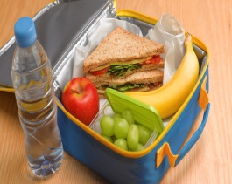
Lunch Box Suggestions: Sandwiches, cream crackers, bread rolls, wraps, pitta, pasta, scone, bread, cold meats, salad, fruit, raw vegetables, cheese, milk, water, fruit juice, smoothies, yogurt drink.
In the interest of health & safety, we require parents to refrain from sending food to classes for celebrations etc.
Chewing/bubble gum is not allowed in the school.
Teachers are not insured to administer medication to children, if vital medication is needed throughout the school day, this must be brought to the attention of the Principal so that administration arrangement can be discussed.
Children can only bring to school the items specified on their book list. Teacher may notify parents throughout the year if other items are needed for educational purposes.

Accidents can occur despite supervision. Minor accidents are treated at school. Slight cuts and grazes are normally treated by cleaning the wound. When a dressing has been put on a wound parents are asked to inspect the wound when the child comes home from school. In the event of a more serious accident/ child becoming ill, every possible effort will be made to contact the pupil’s parents or the person delegated to take responsibility for the pupil. All major accidents are recorded. All parents must sign the First Aid Treatment permission slip, which is on our Registration Booklet. A Health and Safety Statement applies to all employees of Presentation Convent Junior School.
Pupils are encouraged to use walking feet on corridors and stairs for safety. Pupils are encouraged to remain in seats during wet day breaks.
Presentation Convent Junior School and its grounds is a designated non-smoking area.
We are proud owners of several green flags. We care for our environment. Our mottos are: “litter free is the way to be”; “keep it clean, keep it green, no more litter to be seen”; “It’s a snap to turn off the tap”; Stop! Don’t waste a drop!”; “Save our fuel and siúl to school”; “Show the earth you care”; “Be energy aware, switch it off”
We encourage respect for the home and school environment. Your co-operation in keeping our school litter free is appreciated.

Homework:
Homework is part of our overall school policy and it is designed to revisit concepts covered in class. Most nights during the week homework is given, however some nights there may be none for various reasons.
It is important to establish a homework routine. Set aside a quiet regular time when your child can sit comfortably at a table. If your child is working independently, be available to help and show an interest in what is being done. Praise your child for his/her efforts at every opportunity. If you feel yourself becoming impatient when working with your child, stop, as to continue will only have a negative effect. Encourage your child to not only complete the work but to keep their copies clean, tidy and neat. Presentation is important. If your child is persistently having problems with homework, contact the teacher and discuss these difficulties.
An approximate guideline for the length of time appropriate for homework at different class levels is as follows. These should be looked on as average recommended times rather than strict guidelines as homework will vary:
Junior Infants: 10 minutes Senior Infants: 20 minutes
First Class: 30 minutes Second Class: 40 minutes

Code of Behaviour
Everyone is encouraged to have respect for themselves and everyone else. Please encourage your child to be respectful and mannerly at all times. We encourage pupils to include each other in play. We nurture a positive environment in the playground. The mantra “I am responsible for me, hands to myself, feet to myself and think before I do or say” is often repeated before break time.
We encourage our pupils to use their words to explain their issues. Our code of behaviour is tailored to answer any behaviour issues.
Our Golden Rules: Be gentle. Be kind and helpful. Be Honest. Listen well. Work Hard. Look after property.
The entire code is available on our web page. All policies are posted on our website (details on front of booklet).
The Department of Education and Skills has introduced Guidelines and Procedures for all schools in relation to Child Protection and Welfare. We have adopted these guidelines as school policy and we have our Child Safeguarding Statement and the school DLP (Designated Liaison Person).
The Department website www.education.ie has the guidelines. This is by way of notification to parents of the procedures that operate under the guidelines.

Our school is proud of having a specialist infant education programme.

We are a friendly, enthusiastic and talented staff. We are interested in keeping up to date on educational developments and are dedicated to the total development and care of all our pupils. We have well equipped classrooms with computer, interactive whiteboards or Learning Panels. This technology is supported by a range of educational software. We have an attractive playground with markings, playground games and activities to inspire fun. We have a large concert Hall with a stage, professional lighting and a sound system. The Hall has a wide range of P.E. equipment. Our school is within walking distance of all local facilities and places of interest. We offer swimming, dance and if available recorder lessons.

Sample Absence Note:

Absence Report

Child’s Name: __________________________ Room: ______

Please tick reason for absence Dates of Absence
Illness ______________

Family Concern ______________

Holiday ______________

Other Reason - please state: ____________________________

Signature: ___________________________ Date: __________

Uniform Chant
I wear my uniform each day
I respect it in every way
Thanks at home for helping me
Be neat and tidy for all to see

Blue shirt, black shoes, navy all the rest
Every day I try to look my very best
I wear my tracksuit and trainers for PE
That is the way it’s meant to be

No boots or stripy tights allowed
We are Presentation proud

