Presentation Junior School
“A Community of learners inspired by the vision and values of Nano Nagle”
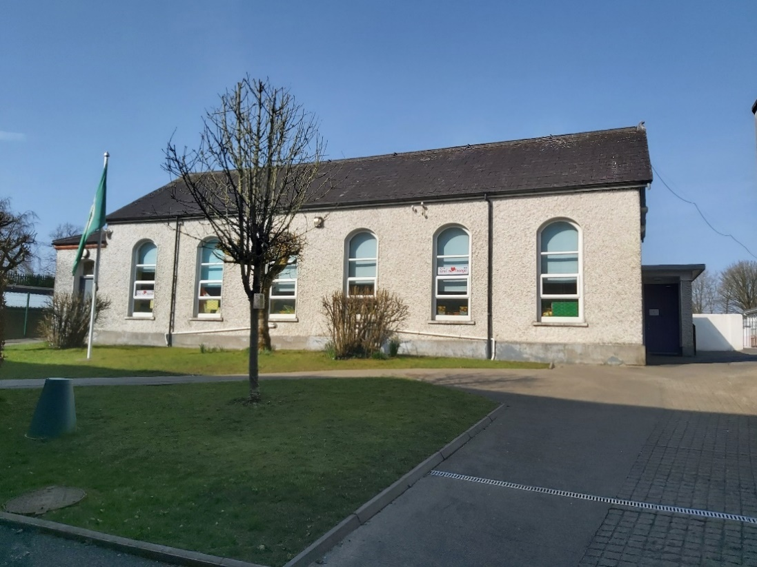

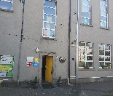

Welcome to Presentation Convent Junior School…
A warm welcome to our school ,
As principal I am delighted and honoured to welcome you and your child to our wonderful school and active school community. Our school is a unique and dynamic environment for your child to grow and develop holistically and feel valued through our many different learning activities delivered by a highly experienced professional team. We are a Junior school catering for Junior Infants to Second Class and are specialised in the area of Infant Education .We encourage the children to be their best and focus on values of kindness, respect and responsibility while we work with your child so they reach their own individual potential as they journey through our school.
We are a co- educational Catholic school and strive to provide for the intellectual, spiritual, physical, moral, social and cultural needs of our children. While our ethos is Catholic we welcome all children of different belief systems in a spirit of respect and understanding.
Starting primary school is a very exciting and special time for you and your child and over the coming school years we will work with you to make it the most wonderful experience. Partnership and team work is essential and our motto Together Everybody Achieves More(TEAM)is at the heart of school life . Here at Presentation Convent Junior School we work together and through partnership with children, staff and parents all children are encouraged to reach their full potential.
Le mór meas,
School Principal

Our Mission Statement
To educate our children to their fullest potential, in an environment where Christian values are fostered, where they are happy, safe, respect themselves and others and where each feels valued.
Our Ethos
Our school is Catholic in character, inclusive in our intake and comprehensive in our curriculum. Our behaviour management strategies and structures are built on the principles of justice and fairness. We endeavour to fulfil our mission in partnership with management, parents, staff, students, parish and the local community. We welcome all those with other belief systems with a culture of learning, respect and tolerance.
About Our School
Presentation Convent Junior School is an infant school and is situated in the centre of Mullingar town, and we share the same campus with Presentation Convent Senior School. Our school has fourteen mainstream classes, a Speech and Language class and our Sunshine Room caters for children with ASD. We have Junior Infants to Second class in our school. Our school curriculum covers aspects of English, Irish, Maths, Physical Education, Social, Environmental and Scientific Education, Relationships and Sexuality Education, Music and Drama and your child will explore these areas at an age-appropriate level. Our staff have developed our very own individual Oral Language Programme.
We have a large hall and play area, garden area and sensory rooms for the children with lots of equipment and resources to make learning fun and interactive. Our classrooms are well resourced with literacy and numeracy resources, digital technology, and lots of toys!! We have a fantastic team of experienced teachers and in partnership parents we strive to ensure that your child achieves their individual potential. We have lots of opportunities for the children to try out GAA, Athletics, Swimming, Karate, Tennis,Rugby, Basketball and Yoga.
Our school is managed by our Board of Management, and we also have a Parents Association.

School Information
School Address: Presentation Junior School, Harbour Street, Mullingar, Co. Westmeath
Telephone:044934216 / 087 7005130
Website: www.presentationmullingar.ie
School Times:
Junior and Senior Infants:8.50am -1.30pm
First and Second Classes: 8.50am-2.30pm
Enrolment takes place for all schools in the parish in January-enrolment forms will be available on our website or pop into our school office.
Presentation Convent Junior School and its grounds is a designated non-smoking area.
School Uniform
Thank you for ensuring your child wears the school uniform every day. The school tracksuit and trainers can be worn on PE day only. Thank you for taking pride in the uniform by ensuring it is clean, tidy and in good condition.
Girl’s uniform: Navy pinafore or navy skirt or navy trousers. Light blue blouse. Navy socks or tights. Black shoes (no high heels, platforms). Trainers for PE day.
Boy’s uniform: Navy trousers. Light Blue Shirt. Navy socks. Black shoes. Trainers for PE day.
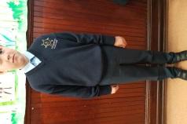
School jumper/cardigan with crest available from Tots Paradise, Blackhall Place just off Mount St. and from The Uniform Shop in the Enterprise Centre, Bishopsgate St.
PE Tracksuit with school logo is available through the school only at a price of €35. A white polo shirt to be worn under the tracksuit top can be bought in any shop.
When you visit the Junior Infant teacher there will be an opportunity to order your tracksuit or alternatively you can order one through the office.
Please put your child’s name and room number on uniform, tracksuit and all belongings. As there may be many similar school coats please think of some way your child can easily recognise his/her coat.
Please ensure hair is clean and neat. If hair is long it is best to have it tied back neatly.
Please ensure that your child has a school bag that they can manage and that will fit an A4/A3 size folder and their lunch.

Home School Communication
We believe the relationship between home and school is very important. We encourage you to take great interest in your child’s work in school. Our school needs your participation and talents to be a vibrant place of education. In order to keep you informed of important information we operate a text a parent service called Aladdin. It is vital we have your most up to date mobile number at all times. Please notify us immediately of any change of address, phone or mobile numbers. We also need contact numbers in the event of an emergency and we cannot contact you.
Annual Parent /Teacher meetings are held during the year, generally in November. The teacher may be available for an informal meeting at dismissal time and this will be facilitated if possible. If you wish to speak with the teacher/Principal at other times please contact Reception for an appointment or email the school.
Our Golden Rules
Be Gentle
Be Kind and Helpful
Be Honest
Listen Well
Work Hard
Look after Property

Everyone is encouraged to have respect for themselves and everyone else. We encourage pupils to include each other in play. We nurture a positive environment throughout our school. The mantra “I am responsible for me, hands to myself, feet to myself and think before I do or say” is often repeated before break time. We encourage our pupils to use their words to explain their issues. Our Positive Behaviour Policy is tailored to answer any behaviour issues. Our Positive Behaviour Policy is available on our web page.

Attendance and Punctuality
The school will be open to receive pupils at the official opening time of 8.50a.m. We encourage all children to attend school every day.
The school accepts no responsibility for:
- children arriving before that time
- children remaining in the school or school grounds after school hours
- children coming to school or going home from school.
If a child needs to leave school during school hours for a medical appointment or other reason a parent/guardian must first send a note or via Aladdin to the class teacher with details of date, time, the reason and signed by parent/guardian. If someone other than a parent is collecting a child the school must also be notified. The parent must call to reception (yellow door) and the Secretary will collect the pupil from the classroom. You will be required to sign your child out of the school. Please minimise early leaving as your child is missing out.
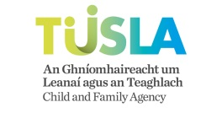
If a pupil is absent you must notify the school by Aladdin, a text ,email or call the office. If a child is absent for more than 20 days we must send his/her name to TUSLA’s Education Welfare Service.
Please collect your child on time each day.

Health & Safety/School Lunches
Presentation Convent Junior School wishes to promote a healthy lifestyle in the development of the children in the school. Accordingly, the following points are to be noted.
- Children who are ill should not be asked to go to school.
- Parents are asked that teachers be made aware of any disability, allergy, etc. that their child may have.
As you are aware, any child’s hair may become infected with head lice. You are asked in the interest of your own, and all the other children in the class, to check your child’s hair at least twice a week. It is necessary to have a good fine comb for this purpose. If the hair is infected, please treat with one of the lotions available from the chemist. In order to minimise the risk, please keep long hair tied up, plaited or in a bun.
Parents are asked to give a small nourishing lunch to children. Fizzy drinks, sweets, chips, crisps, fruit winders, sugary/chocolate coated cereal bars, chocolate and nuts are not allowed. Each child must have a lunch box with his/her name on it. Uneaten lunch should be brought home in their lunchboxes. In the interest of health & safety, we require parents to refrain from sending food to classes for celebrations or birthdays. Chewing/bubble gum is not allowed in the school.
Lunch Box Suggestions: Sandwiches, cream crackers, bread rolls, wraps, pitta, pasta, scone, bread, cold meats, salad, fruit, raw vegetables, cheese, milk, water, fruit juice, smoothies, yogurt drink.

If vital medication is needed throughout the school day, this must be brought to the attention of the Principal so that administration arrangements can be discussed. Children can only bring to school the items specified on their book list. Teacher may notify parents throughout the year if other items are needed for educational purposes.

Accidents can occur despite supervision. Minor accidents are treated at school. Slight cuts and grazes are normally treated by cleaning the wound. When a dressing has been put on a wound parents are asked to inspect the wound when the child comes home from school. In the event of a more serious accident/child becoming ill, every possible effort will be made to contact the pupil’s parents or the person delegated to take responsibility for the pupil. All major accidents are recorded. All parents must sign the First Aid Treatment permission slip, which is on our Registration Form.

Homework:
Homework is part of our school routine and it is designed to revisit concepts covered in class. Most nights during the week homework is given, however some nights there may be none for various reasons.
It is important to establish a homework routine. Set aside a quiet regular time when your child can sit comfortably at a table. If your child is working independently, be available to help and show an interest in what is being done. Praise your child for his/her efforts at every opportunity. Encourage your child to not only complete the work but to keep their copies clean, tidy and neat. Presentation is important.
An approximate guideline for the length of time appropriate for homework at different class levels is as follows. These should be looked on as average recommended times rather than strict guidelines as homework will vary:
Junior Infants/Senior Infants: 10/15 minutes
First Class/Second Class: 20/30 minutes
If your child is persistently having problems with homework, contact the teacher and discuss these difficulties.
Child Protection Procedures
The Department of Education and Skills has introduced Guidelines and Procedures for all schools in relation to Child Protection and Welfare. We have adopted these guidelines as school policy and we have our Child Safeguarding Statement, this can be viewed on our website. The Designated Liaison Person for Presentation Convent Junior School is Natasha Miskell and the Deputy Designated Liaison Person is Alma Manny for all child protection related issues in the school. The Department website www.education.ie has the guidelines. This is by way of notification to parents of the procedures that operate under the guidelines.

School Policies
Please have a look at our school policies which can be found on our website www.presentationmullingar.ie
- Positive Behaviour Policy;
- Anti-Bullying Policy;
- Critical Incident Policy;
- Health and Safety Policy;
- Attendance Statement Strategy;
- Admissions Policy;
- Child Protection and Risk Assessment.
We look forward to meeting you and your child and working together as you join our school community!!

