Happy Mid-Term | Presentation Junior School  “A Community of learners inspired by the vision and values of Nano Nagle”

Well done to all on a super Spring term term at school, it has been really busy and the boys and girls have worked very hard and are looking forward to the mid-term break.

La Fhéile Valintín daoibh go léir!!!

Miss Miskell and all the Staff
Health and Safety | School Activities -February
Thank you to all our parents, guardians and children for adhering to our health and safety protocols, making our school a safer place. There is a no-smoking policy on our school grounds. Please lock any scooters and bicycles that are left in our bike racks in our bicycle shed. | - Karate – All Senior Infants  - GAA – All First/Second Classes(April)  - Tennis-Senior Infants  - Dance – First Class  - Yoga-Junior/Second Class  - Swimming – Rooms 9 and 12  - Recorder-All Second Classes
School Uniform | Attendance and Punctuality
We are very proud of our school uniform and it the children must wear the school uniform everyday (Navy trousers/Navy pinafore, blue shirt and their school jumper or cardigan) except on days they have a P.E. lesson and they wear their P.E. tracksuit. We expect all pupils will wear the correct school uniform every day. | Regular school attendance is so important for your children. Early collections for essential appointments only. All children are required to be signed out of the school building, giving a reason for the early collection/late arrival. Our January attendance was 89.5%, let’s try and increase this in February.
School Completion Programme | Home School Community Liaison News
Lisa Murtagh is our school completion worker. Lisa works with different children and families in our school. She is also running a programme called Roots of Empathy with Miss Earley’s First Class in Room 13. We have started our homework club on a Tuesday and Thursday evening. Well done to all involved, it is working really well. | Miss Byrne will be running courses and events that may be of interest to you as parents. If you would like to get involved or have any suggestions or ideas please contact Miss Byrne on 087 6529870.Miss Hughes will be welcoming some of her parents into the class to participate in Maths activities.
Presentation Junior celebrate the 100th Day of School
On Wednesday 7th February we celebrated the 100th day of our school term, this is an annual day on our calendar-it represents learning for 100 days. We are one hundred times smarter and have learned so much.  Many of our students received certificates for 100% attendance meaning these children missed no days for the whole year which is pretty remarkable!!  It is so important for your child to be in school for their learning, friendships and academic progress. | 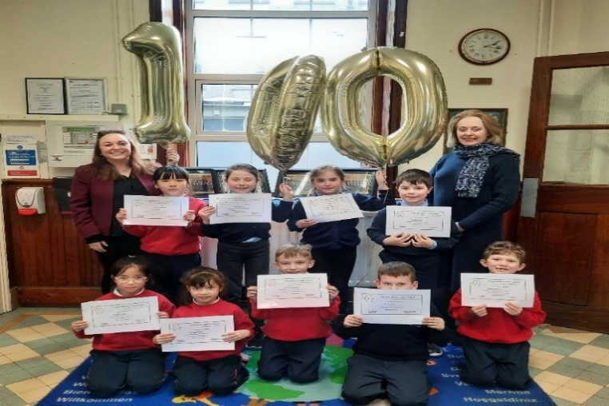
Challenge to Change-World Harmony Day 21st March
As part of our annual Challenge to Change Project  we hope to hold a Multi-Cultural Fair and Bake sale in school on 21st March. Last year if you remember we celebrated World Penguin Day!!!  Calling all crafters and artists!!!!  We need your help to make and create suitable items that could be sold on that day. As we are a school with a large number of pupils we will need quite a lot of items. So if anyone is crafty and creative we need you and your skills!!!!! | We will need items that would be attractive to the children and to parents/ guardians. This fair will be held during school hours and all help would be greatly appreciated!!  Items such knitted goods, crocheted/needlework keyrings/purses/bookmarks/cards would be really great. Have a look on Pinterest for ideas!!! We will also have a bake sale. Please contact the office if you have any questions or have an idea -looking forward to World Harmony Day 2024!
School Fees | Parents Association News
Thank you to all who support our school and who have paid their school fees. This money is used to purchase essential items for your child. Should you wish to discuss a payment plan please contact the office. We will be in touch in the coming weeks. | Our Parents Association work very hard to support the work of the school. Sarah Greville is the Chairperson of the Parents Association. They are always looking for new members, if anyone is interested in joining our parents Association please pop into the office. They are currently working on an Easter idea!!!!!
School Website | Tin Whistle Classes
We are working very hard on our school website, and it is almost completed. It will be a useful resource to keep up to date with school life and check in for information that you may need about our school. There will be a link to the Senior School which will be useful if you have children in both schools. | Tin Whistle classes have begun for children in Second Classes. These classes take place after school until 3.00pm on a Wednesday afternoon. Miss Walsh and Miss Earley are the teachers. All your child needs is a D tin whistle which can be purchased locally .Please let us know if your child is interested.
Diary Dates | Contact Information
Mid-Term Break-Thursday15th/Friday 16th February  First Confession-February 19th @ 6pm in Christ the King Cathedral  Lá Glas- Friday 3rd March  St Patricks Day-Monday 16th March  Easter Holidays- March 25th-April 5th  First Communion- Sunday 18th May @1.00pm in Christ the King Cathedral | Principal: Natasha Miskell  Address:  Presentation Convent Junior School,  Mullingar,  Co. Westmeath.  N91 CXK0  Office Phone: 044 934 2166  School Mobile: 087 7005130  Email: adminjnr@presentationmullingar.ie  Website: www.presentationmullingar.ie

